Python for Engineers
Course Project Report on
“DRIVER DROWSINESS DETECTION SYSTEM USING OPENCV”
SUBMITTED IN PARTIAL FULFILLMENT OF THE REQUIREMENTS FOR THE DEGREE OF
BACHELOR OF TECHNOLOGY IN
“CSE(AI)-F”

OF
VISHWAKARMA INSTITUTE OF TECHNOLOGY

Savitribai Phule Pune University
Shourya Hiwase (1251090340)
UNDER THE GUIDANCE OF
“Prof: Snehal Shinde”


DEPARTMENT OF ENGINEERING SCIENCE AND HUMANITIES

BANSILAL RAMNATH AGARWAL CHARITABLE TRUST’S
VISHWAKARMA INSTITUTE OF TECHNOLOGY
(An Autonomous Institute affiliated to Savitribai Phule Pune University)

2025 - 2026
BANSILAL RAMNATH AGARWAL CHARITABLE TRUST’S

VISHWAKARMA INSTITUTE OF TECHNOLOGY
(An Autonomous Institute affiliated to Savitribai Phule Pune University)

PUNE – 411037


CERTIFICATE

This is to certify that the Course Project titled “DRIVER DROWSINESS DETECTION SYSTEM USING OPENCV” submitted by SHOURYA HIWASE(1251090340) is in partial fulfillment for the award of Degree of Bachelor of Technology in CS-AI of Vishwakarma Institute of Technology, Savitribai Phule Pune University. This project report is a record of bonafide work carried out by him/her under my guidance during the academic year 2025-26.

Guide HOD, DESH
Prof. Snehal Shinde Prof. Dr. S. M. Lambor
Place: VIT, Pune
Date: 8/01/26

Bansilal Ramnath Agarwal Charitable Trust’s

Vishwakarma Institute of Technology, Pune-37
Department of Engineering Science and Humanities

PROJECT DETAILS

Group No : 2
Members:
Roll No. | PRN | Name of Student | Contact No. | Email ID
05 | 1251090144 | Shirure Omkar | 9373991990 | omkar.1251090144@vit.edu
07 | 1251090340 | Shourya Hiwase | 9370937669 | shourya.1251090340@vit.edu
08 | 1251090464 | Shreya Mete | 9549542572 | shreya.1251090464@vit.edu
09 | 1251090244 | Shreya Singh Senger | 9435637192 | shreya.1251090244@vit.edu

Academic Year : 2025-26
Project Title : “DRIVER DROWSINESS DETECTION SYSTEM USING OPENCV”
Project Area : Automobile
Internal Guide : Prof. Snehal Shinde

Signature of Internal Guide

ACKNOWLEDGEMENT

We would like to express our sincere gratitude to Dr. Shilpa Lambor, Head of the Department (DESH), for their valuable guidance and encouragement throughout this project. Their insightful feedback and support have been instrumental in shaping this work. We would also like to extend our heartfelt appreciation to Prof: Prachi Pawar, our subject teacher, for their continuous support, expertise, and constructive suggestions. Their dedication and knowledge have greatly helped us understand the nuances of data analysis and successfully complete this project. Furthermore, we are grateful to institution and peers who provided necessary resources, discussions, and motivation throughout this journey. Lastly, we extend our thanks to my family and friends for their encouragement and unwavering support.

Shourya Hiwase (1251090340)
Shreya Mete (1251090464)
Shirure Omkar (1251090144)
Shreya Singh Senger (1251090244)

- Introduction

As we already live in an era where everything is fast and quick, it has been observed that a high proportion of road accidents occur as drivers get drowsy or loose consciousness while driving thus a resulting of slow vehicular response or no response at all. To counter this, modern cars and many research systems are now employing camera‑based approaches which continuously observe the driver’s face and eyes for evidence of sleepiness.
This initiative presents a real‑time driver sleep detection system implemented in Python with the help of OpenCV computer vision library. The system employs a camera aimed at the driver's face to scrutinise eye-activity frame by frame, identifying when eyes have remained shut for a length of time that could potentially indicate drifting off. When sleepiness is detected, this is passed to the system and an audible alarm is automatically activated, causing the driver to wake up and pay attention which also enhances traffic safety and could save from serious crashes. ​
This approach works as a non‑invasive, low‑cost solution using the standard camera and software (Instead of complicated sensors), which is suitable for a prototype integration into cars or driver simulators/driver monitoring applications.

- LITERATURE REVIEW
Sr. No. | Title of research paper | Authors | Journal / Conference | Date of publication (Month, Date, ear) | Brief summary (2–3 lines) | Remark
1 | Driver Drowsiness Detection System Using Python, OpenCV and Raspberry Pi | Not clearly specified (STM Journals editorial authorship) | Trends in Opto-Electro & Optical Communication (STM Journals) ​ | 2023 (exact month and day not specified) ​ | Presents a real-time drowsiness detection system using Python and OpenCV on Raspberry Pi to detect the driver’s eyes and compute EAR. When EAR stays below a threshold for several frames, the system concludes the driver is sleepy and activates a buzzer. ​ | Very similar to your project; supports using EAR, a camera and an audible alarm as a low-cost, non-invasive drowsiness detector. ​
2 | Driver Drowsiness Detection Using OpenCV & Dlib | S. Kumar et al. | International Journal of Creative Research Thoughts (IJCRT) ​ | May 2023 (exact day not specified) ​ | Uses OpenCV and dlib facial landmarks to compute EAR and monitor eye blinks and closures in real time. When eyes remain closed for several frames, the system changes the face-box color and triggers an alert, achieving good accuracy. ​ | Strong reference for EAR + landmark-based eye monitoring with Python; directly supports frame-by-frame eye analysis and alarm activation. ​
3 | Drivers Drowsiness Detection System Using OpenCV | Multiple authors (JETIR) | Journal of Emerging Technologies and Innovative Research (JETIR) ​ | 2025 (volume 12, issue 9 – exact day not specified) ​ | Proposes a non-intrusive driver monitoring system where a camera observes the driver’s face, extracts eye landmarks and computes EAR to detect prolonged eye closure. When drowsiness is detected, an alarm warns the driver to prevent accidents. ​ | Recent OpenCV-based work; supports feasibility of a low-cost real-time prototype using only a standard camera. ​
4 | Driver Drowsiness Detection System with OpenCV & Keras | Multiple authors | International Journal of Modern Research in Engineering and Science (IJMRSET) ​ | 2023 (exact month and day not specified) ​ | Captures real-time images using OpenCV and feeds eye-region crops into a Keras deep-learning model to classify eyes as open or closed. Drowsiness is detected based on predicted state and closure duration, and alerts are issued to the driver. ​ | Shows how OpenCV can be combined with deep learning for better robustness; useful as an advanced extension of your threshold-based system. ​
5 | Non-Intrusive Driver Drowsiness Detection based on Face and Eye Tracking | F. A. Khan et al. | International Journal of Advanced Computer Science and Applications (IJACSA) ​ | July 30, 2019 ​ | Describes a non-intrusive drowsiness detection method using face and eye tracking from a camera without any physical contact with the driver. Eye closure and blink patterns are analyzed to infer fatigue and generate warning signals. ​ | Good conceptual reference to justify a camera-only, non-invasive driver monitoring system similar to your OpenCV-based prototype. ​

- Methodology

A program that uses OpenCV, NumPy and Winsound to import necessary packages, initialize variables for counting frames when a person's eyes are closed

The program initializes as follows:

- It loads preloaded Haar Cascade classifiers from OpenCV for face and eye detection.

- It uses cv2.VideoCapture( 0 ) to start capturing video frames in real time from your computer's webcam.

- After each frame is captured, the program flips the frame around horizontally and converts it to grayscale so that it uses less processing power.

- The face detector scans the grayscale image for a face and determines where the face is located in the image.

- The program then crops out the image of the detected face and only uses that part of the image when running the eye detector.

- The program will then check if two eyes were detected, if they were the program will call that Eyes Open and reset the counter, if two eyes were not detected the program will assume those eyes are closed and increment the counter for each frame that the eyes remain closed.

- Once the counter goes above the threshold value of FRAME_CHECK, the program will interpret the person's prolonged closing of their eyes as possibly being drowsy.

- The program will display a visual alert on your screen and will also make an audible beep using winsound.Beep().

- The video containing your label, visual alert, and sound alert will continue to display on your computer monitor until you hit 'q'.

- The program will then safely close all OpenCV windows and release access to the webcam.

4.Features provided by an application

The system is able to capture real-time video images from a normal camera and use OpenCV methods to detect the face and eyes of the driver.
Moreover,
​
The Eye Aspect Ratio measure is calculated for each frame, indicating whether a driver’s eyes are open or shut.

The system also monitors constantly the duration of eye closure in order to make a distinction between blinking and drowsiness/micro-sleep.

If the eyes are not closed within a specified time threshold, the system will trigger an alarm if it detects the driver is drowsy. ​ The proposed system does not require invasive and costly components, as only a webcam and software are used. Example The simplified interface on the screen would be capable of displaying the status messages such as “Awake” and “Drowsy” so that the vehicle driver knows the current status of the system's analysis.
5.IMPORTANT FEATURES OF CODE (PYTHON)

# Step 1 - Open Webcam (Video)
cap = cv2.VideoCapture(0)

while True:
# Read frame
ret, frame = cap.read()
if not ret:
break

# Step 2 - Load Cascade Classifier for Faces and Eyes
face_cascade = cv2.CascadeClassifier(cv2.data.haarcascades+'haarcascade_frontalface_default.xml')
eye_cascade = cv2.CascadeClassifier(cv2.data.haarcascades+'haarcascade_eye.xml')

# Step 3 - Convert frame colour space to Grayscale (for Improved Speed)
gray = cv2.cvtColor(frame, cv2.COLOR_BGR2GRAY)

# Step 4 - Detect Faces in the Grayscale Image
faces = face_cascade.detectMultiScale(gray, 1.2, 5)

for (x,y,w,h) in faces:
face_gray = gray[y:y+h, x:x+w]

# Step 5 - Detect Eyes within Face Region
eyes = eye_cascade.detectMultiScale(face_gray, 1.1, 4)

# Step 6 - Logic: Count Number of Closed Eyes
if len(eyes) >= 2:
FLAG = 0
else:
FLAG += 1

# Step 7 - If Count Exceeds FRAME_CHECK then Sound Alarm
if FLAG >= FRAME_CHECK:
cv2.putText(frame, '*****ALERT!*****',(20,80),cv2.FONT_HERSHEY_SIMPLEX,1,(0,0,255),3)
winsound.Beep(1000,800)

# Step 8 - Clean Up and Exit Program
if cv2.waitKey(1) & 0xFF == ord('q'):
break

cap.release()
cv2.destroyAllWindows()

6.Screenshots of results

Screenshot no.1
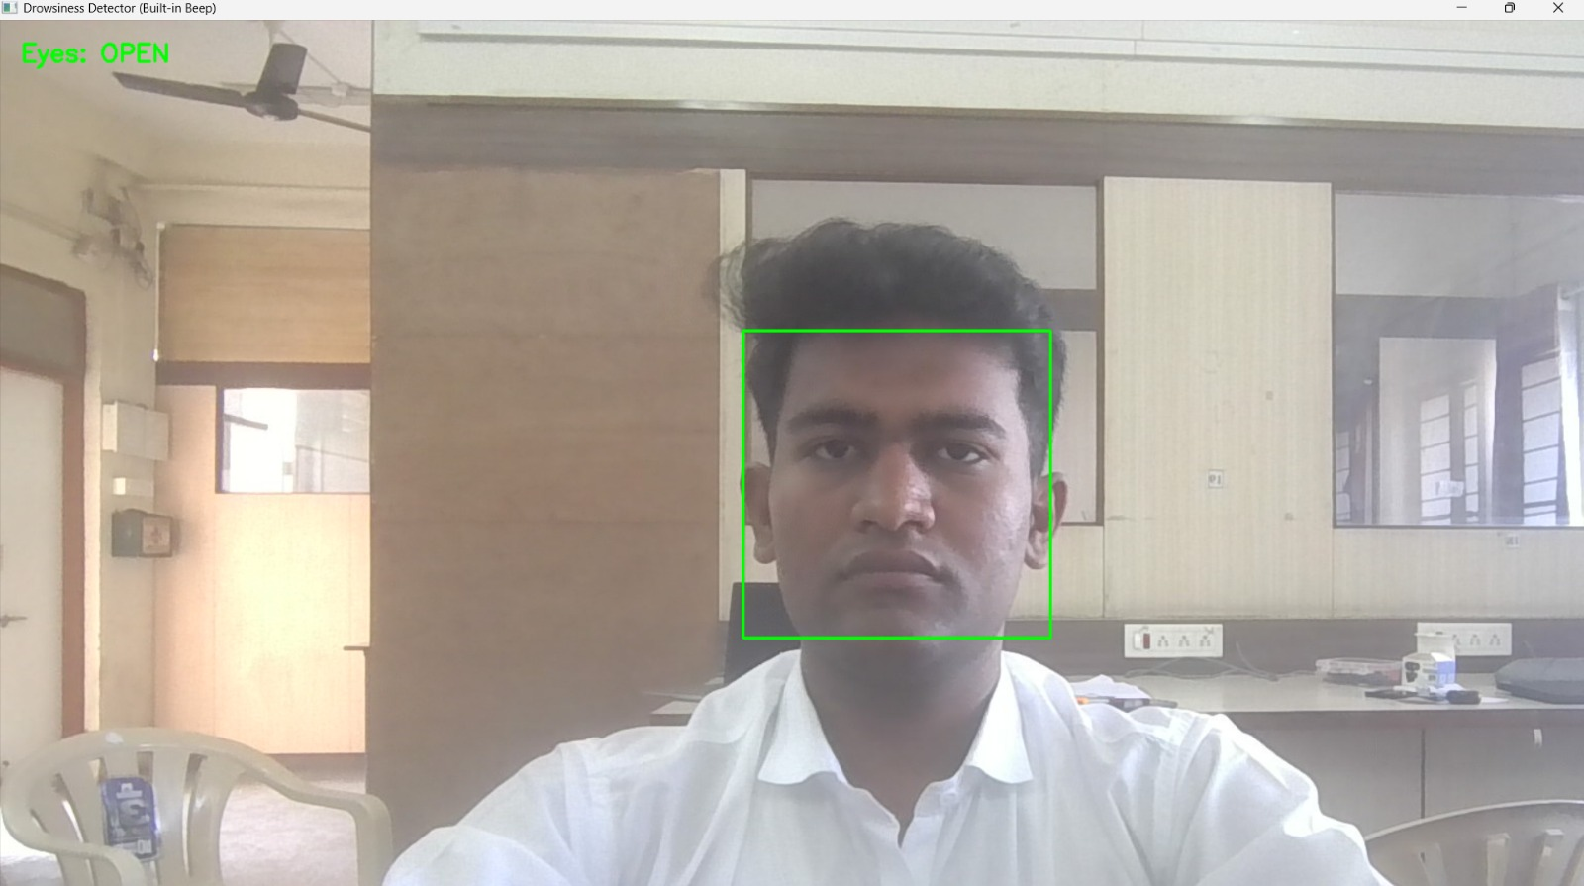
Explanation
. The image shows the real-time output of the drowsiness detection system using a webcam. The green bounding box indicates successful face detection using Haar Cascade. The text “Eyes: OPEN” in green confirms that both eyes are detected, meaning the system considers the user alert. Since eyes are open, the closed-eye frame counter is reset and no alert or beep is triggered. This image demonstrates correct face detection, eye detection, and normal system operation without drowsiness detection.

Screenshot no.2
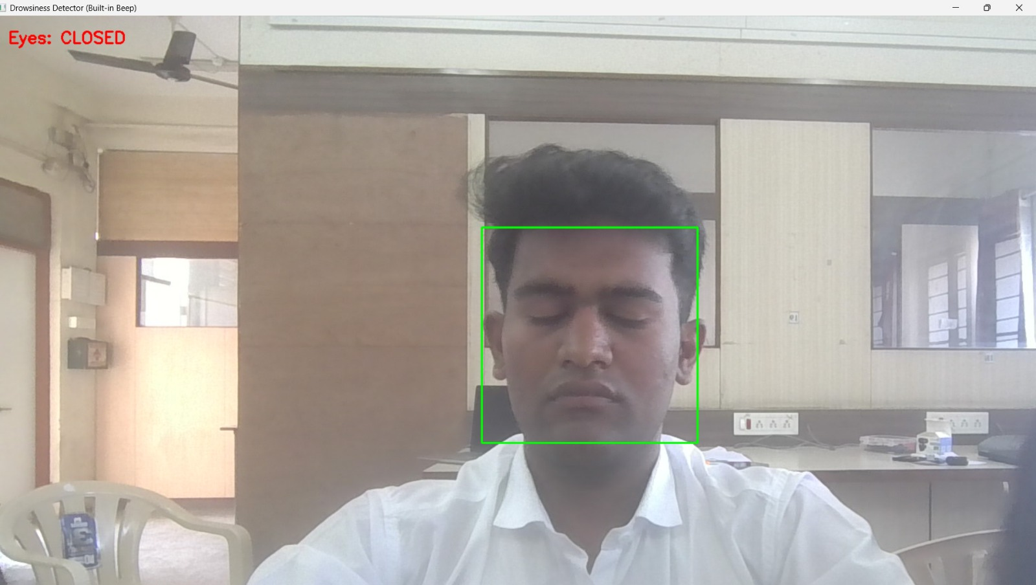
EXPLANATION

This image represents the drowsy condition detection in the project. The green rectangle shows that the face is correctly detected. The text “Eyes: CLOSED” in red indicates that the eye detector is not detecting open eyes in the current frame. As a result, the system increases the closed-eye frame counter. If this condition continues for the predefined number of frames (FRAME_CHECK), the system will trigger a drowsiness alert with a beep sound. This image confirms that the system correctly identifies eye closure and moves toward alert generation.

7.Conclusion

The real-time driver sleep detection system designed using Python programming along with the OpenCV computer vision library offers an intelligent and efficient solution to counter the ever-prevalent factor that leads to a large number of accidents on the roads—a sleeping or dozing driver behind the wheels. In the contemporary world where long driving sessions along with the consequent fatigue have become the norm, the system acquires vital significance to ensure the safety of the roads along with preventing accidents. The detection made possible using the usual camera picks up images of the driver’s eye movements to check whether the driver is dozing off. If the eyes close for a specified time, the alarm goes off automatically to warn the driver.

This new method differs from the usual sensor formulation approaches because it presents an efficient and low-cost solution, and its implementation does not require many changes in the vehicle models and driver monitoring systems. In addition, it shows how open-source software, such as Python and OpenCV, can be utilized to solve real-world problems involving intelligent transport systems.
However, the effectiveness of such a system proves the increasing potential of various machine learning and image processing techniques in improving the efficiency and effectiveness of driver-assistance systems. After improving the areas such as adaptability to environmental changes even in low-light conditions, handling multimodal fatigue detection techniques such as facial landmarks and yawning, and adding integration with vehicular control systems, such a project could become a functional module for ADAS technology.

Finally, it can be concluded that the proposed model not only emphasizes the significance and role of technology in mitigating human errors on the road, but at the same time, it helps to create smarter and safer ways for transport infrastructure. The proposed model offers a promising platform for future research and development in area of driver monitoring and provides an effective solution for reducing accidents and making a positive social impact.
8.Future Scope

Integrate other behavioral cues like yawning, head pose, and gaze direction to further ensure robustness in real driving scenarios beyond only eye status.
All right, choose one from the above mentioned.

Replace fixed EAR thresholds by machine-learning or deep-learning models that can learn from different drivers, under various lighting conditions and camera position.

It becomes the harmonic series:

Merge camera‑based monitoring with other signals: steering behavior, lane deviation, or simple physiological sensors can be used to create a hybrid, more reliable drowsiness detector.

​ Deploy the system on embedded hardware, either the Raspberry Pi or the NVIDIA Jetson, together with its integration into an in‑vehicle HMI to make it applicable within real cars, not just within a simulated environment. ​ The salt that was added to water would, therefore, greatly help get a clearer differentiation between colors in making this diagram. Add data logging and cloud connectivity to record drowsiness events, facilitating fleet-level analytics and preventive safety interventions.

9.References

1. F. T. Alshaqaq et al., “A Review of Recent Developments in Driver Drowsiness Detection Systems,” Sensors, vol. 22, no. 5, 2022.

2. S. Younis et al., “NON‑INTRUSIVE DROWSINESS DETECTION TECHNIQUES AND SYSTEMS,” International Journal of Academic Research in Business and Social Sciences, 2022.

3. F. A. Khan et al., “Non‑Intrusive Driver Drowsiness Detection based on Face and Eye Tracking,” International Journal of Advanced Computer Science and Applications (IJACSA), vol. 10, no. 7, July 2019.

4. A. B. Mohammed et al., “System and Method for Driver Drowsiness Detection Using Deep Neural Networks,” Electronics, vol. 12, no. 3, Jan. 2023.

5. A. M. Alotaibi et al., “Real‑Time Deep Learning‑Based Drowsiness Detection,” Sensors, vol. 23, no. 14, July 2023.

6. P. S. Shinde et al., “Driver Drowsiness Detection System using OpenCV and Python,” IJARIIE, 2023 (project‑type paper using Python + OpenCV).

7. B. Sankar et al., “Driver’s Drowsiness Detection,” B.E. Project Report, Hindustan Institute of Technology and Science, 2020.

